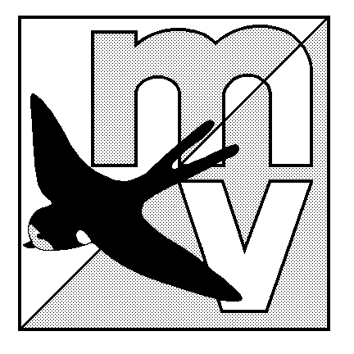MOLE VALLEY ORIENTEERING CLUB
(affiliated to British Orienteering)

LIMITED DISTRICT EVENT

The Nower, Dorking
Monday 25th May 2009

(being run in conjunction with the 32nd Surrey Hill Races – see www.sloweb.org.uk for details)

Venue: Small but interesting area of mostly runnable woodland, with many paths. All facilities are close together, and there is an ideal grassy area to have a picnic on after your run (weather permitting!)

Car Park: The Priory School, Dorking, Surrey. OS Map 187, at Grid Ref TQ158488. Follow the ‘Hill Race’ signs from South end of Dorking one-way system. Parking will be tight - please share transport where possible.

Map: 1:5000, 5m contours - maps are overprinted but not bagged.

Registration: 10.00am - 12.00pm Entry on the day only.

Starts: 10.30am - 12.30pm Courses close 2.30pm

Courses: White(1.4km) Yellow (1.8km), Short Green(3.1km) and Green(4,7km) .
The event will be using SportIdent electronic punching (hire charge £1).

Fees: Seniors £5.00 Juniors £2.00

Facilities: Squash, toilets. Dogs welcome.

Officials: Organiser - Neil Lewer (07843 525232)
Planner - Mike Elliot

MV Website: http://www.mvoc.org/

Safety: Whistles recommended.

IN THE INTEREST OF SAFETY ALL COMPETITORS MUST REPORT TO DOWNLOAD
Competitors participate in this event at their own risk

